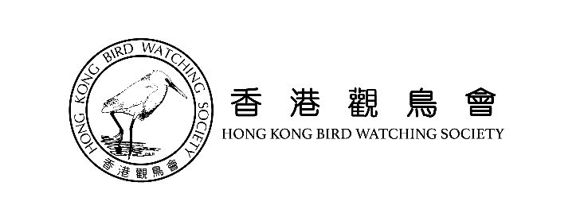
Hong Kong Sparrow Census 2019
Binoculars Borrowing Form for Surveyor
Borrowing Notice and Deposit Receipt

Borrower’s name:
Phone no.: (Mobile)______________________ (Other)
Brand and PIN of gear borrowed:
Deposit amount: HKD800
Deposit payment method: Cash / Cheque (cheque no.: )
Borrower’s signature: Date：
HKBWS staff: HKBWS chop:
-------------------------------------------------------------------------------------------------------
Binoculars Returning and Deposit Collection Receipt
Collector’s (Name) (Signature)
HKBWS staff: Date:
Borrowing reminders:
- Regardless of the reasons causing loss of gear, borrower will be responsible for (1) compensation as market price or (2) purchasing a brand new gear of same brand and model as compensation if the gear is lost.
- Regardless of damages caused by borrower or any other users, borrower will be responsible for (1) the cost of repair or replacement or (2) purchasing a brand new gear of the brand and model as compensation for any human-caused damages or unintended damages.
- Borrower should check the gear condition before borrowing to avoid misunderstanding. Compensation for damages may be exempted if damage(s) is confirmed by HKBWS staff as pre-existing or natural wearing. In case of disputes, the decision of HKBWS shall be final and conclusive.
- This borrowing form is made in duplicate and kept by HKBWS and borrower. This receipt form must be presented upon returning the borrowed gear in order to collect the deposit.
- For any other questions, please contact HKBWS staff at 2377 4387.
Remarks: Please return the binocular on or before _______________________.

